**Date:** 19/09/2016

**Roll No. and Name:** 14BCE154 Chauhan Prasiddh J.

**Course Code and Name:** Open Source Development Lab (CE703)

**Practical No.:** 2 (Perl)

**AIM:** To develop a mini project in Perl for Chat application using Socket Programming

**Input – output:**

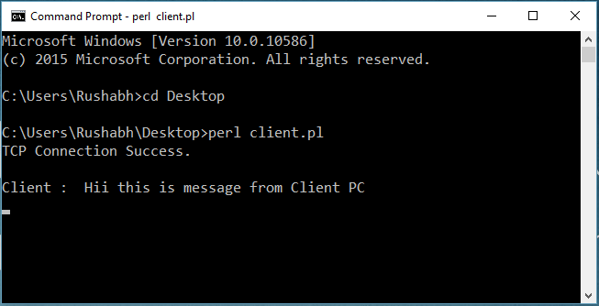

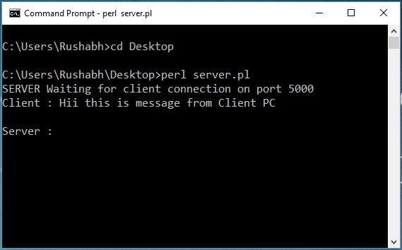

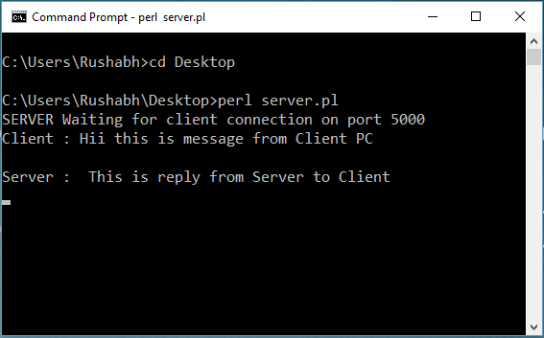

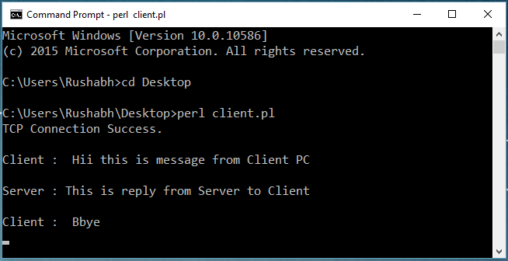

**Conclusions:**

In this project we explored the development of Perl programming and how to implement chat application with the use of socket programming in Perl. Here the main task and the challenge is to establish the secure connection between server and the client using the Transmission Control Protocol (TCP) with local host 127.0.0.1 using the port 5000. After successfully establishing the connection with the client, both can chat with each other. So in nutshell, We learnt so many things in Perl coding through this mini project offered in this course.